Session 2025-2026(EVEN)
Mission: Means to achieve Vision
Vision: Dream of where you want.
Program Educational Objectives of the program (PEO): (broad statements that describe the professional and career accomplishments)
PEO1 | Preparation | P: Preparation | Pep-CL abbreviation pronounce as Pep-si-lL easy to recall
PEO2 | Core Competence | E: Environment (Learning Environment)
PEO3 | Breadth | P: Professionalism
PEO4 | Professionalism | C: Core Competence
PEO5 | Learning Environment | L: Breadth (Learning in diverse areas)

Program Outcomes (PO): (statements that describe what a student should be able to do and know by the end of a program)

Keywords of POs:

Engineering knowledge, Problem analysis, Design/development of solutions, Conduct Investigations of Complex Problems, Engineering Tool Usage, The Engineer and The World, Ethics, Individual and
Collaborative Team work, Communication, Project Management and Finance, Life-Long Learning
PSO Keywords: Cutting edge technologies, Research

“I am an engineer, and I know how to apply engineering knowledge to investigate, analyse and design solutions to complex problems using tools for entire world following all ethics in a collaborative way with proper management skills throughout my life.” to contribute to the development of cutting-edge technologies and Research.

Integrity: I will adhere to the Laboratory Code of Conduct and ethics in its entirety.

Anushka Yede
07-03-2026

Name and Signature of Student and Date
(Signature and Date in Handwritten)

Session | 2024-25 (EVEN) | Course Name | PE:II- Mobile & Web Application for IOT
Semester | 6 | Course Code | 23IOT1623
Roll No | 01 | Name of Student | Anushka Yede

Practical |  | 07
Course Outcome |  | CO1 To understand the different flavors of mobile operating system and their specific features.  CO2 Apply Android applications using various UI controls and layouts.  CO3 Analyze applications capable of data handling and
 |  | communication with native components.
 |  | CO4 Create and develop applications that support multiple devices and configurations.
Problem Definition |  | Develop an Android application that accepts the user&#39;s name using an EditText field. When the user  clicks a button, a Toast message should appear and the application should navigate to another activity  displaying the entered name using Intent data passing. A Snackbar should also be displayed to confirm  the action.
Theory  (100 words) |  | Android applications are built using different UI components and activities. Activities represent different screens of an application. Data can be passed between activities using Intents.  In this experiment, the application accepts the user's name through an EditText field. When the user clicks the Button, the application performs three actions:  - Displays a Toast message to greet the user.  - Shows a Snackbar message to indicate that the application is moving to the next screen.  - Uses an Intent to navigate from MainActivity to SecondActivity, passing the entered name as data.  The SecondActivity receives this data using the Intent and displays a personalized welcome message.  Key Android Components Used:  - EditText – Used to accept text input from the user.  - Button – Used to trigger an action.  - Toast – Displays a small popup message for a short duration.  - Snackbar – Displays a brief message at the bottom of the screen with optional actions.  - Intent – Used to move between activities and pass data.  - TextView – Used to display text on the screen.
Procedure and Execution  (100 Words) |  | • Open Android Studio.  • Create a New Project.  • Select Empty Activity.  • Choose Java as the programming language.  • Create two activities:  - MainActivity  - SecondActivity  • Design the UI in activity_main.xml using:  - TextView  - EditText  - Button  • Write Java code in MainActivity.java to:  - Get user input from EditText  - Display Toast message  - Display Snackbar message  - Pass data using Intent  • Create activity_second.xml layout with a TextView.  • Write Java code in SecondActivity.java to receive and display the name.  • Run the application on an Android Emulator or Physical Device.

Code:
Main Activity Layout (activity_main.xml)

<?xml version="1.0" encoding="utf-8"?>
<LinearLayout xmlns:android="http://schemas.android.com/apk/res/android"
xmlns:app="http://schemas.android.com/apk/res-auto"
android:layout_width="match_parent"
android:layout_height="match_parent"
android:orientation="vertical"
android:padding="20dp">

<TextView
android:layout_width="match_parent"
android:layout_height="wrap_content"
android:text="Enter Your Name"
android:textSize="20sp"/>

<EditText
android:id="@+id/editName"
android:layout_width="match_parent"
android:layout_height="wrap_content"
android:hint="Type your name"/>

<Button
android:id="@+id/btnSubmit"
android:layout_width="match_parent"
android:layout_height="wrap_content"
android:text="Submit"/>

</LinearLayout>

MainActivity.java

package com.example.uievents;

import androidx.appcompat.app.AppCompatActivity;
import android.os.Bundle;
import android.view.View;
import android.widget.Button;
import android.widget.EditText;
import android.widget.Toast;
import android.content.Intent;
import com.google.android.material.snackbar.Snackbar;

public class MainActivity extends AppCompatActivity {

EditText editName;
Button btnSubmit;

@Override
protected void onCreate(Bundle savedInstanceState) {
super.onCreate(savedInstanceState);
setContentView(R.layout.activity_main);

editName = findViewById(R.id.editName);
btnSubmit = findViewById(R.id.btnSubmit);

btnSubmit.setOnClickListener(new View.OnClickListener() {
@Override
public void onClick(View view) {

String name = editName.getText().toString();

// Toast message
Toast.makeText(MainActivity.this,
"Hello " + name,
Toast.LENGTH_SHORT).show();

// Snackbar message
Snackbar.make(view,
"Moving to next screen",
Snackbar.LENGTH_LONG).show();

// Intent for navigation
Intent intent = new Intent(MainActivity.this, SecondActivity.class);

// Passing data
intent.putExtra("username", name);

startActivity(intent);
}
});
}
}

Second Activity Layout (activity_second.xml)

<?xml version="1.0" encoding="utf-8"?>
<LinearLayout xmlns:android="http://schemas.android.com/apk/res/android"
android:layout_width="match_parent"
android:layout_height="match_parent"
android:gravity="center"
android:orientation="vertical">

<TextView
android:id="@+id/textResult"
android:layout_width="wrap_content"
android:layout_height="wrap_content"
android:textSize="24sp"/>

</LinearLayout>

Output:
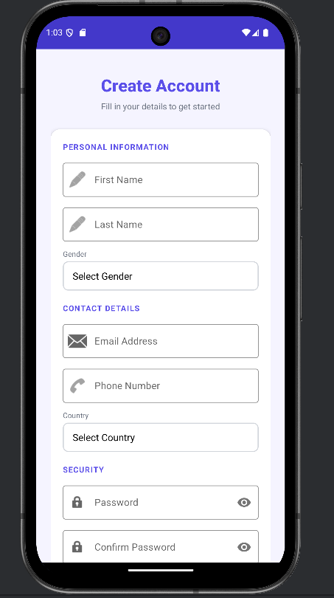
Output Analysis |  | This application demonstrates how different Android UI components and event handling mechanisms work together. The EditText component successfully captures user input, while the Button triggers the click event. The Toast and Snackbar provide feedback to the user, improving user interaction.  The Intent mechanism allows smooth navigation between activities and enables data transfer between screens. This technique is commonly used in Android applications for passing user information between different parts of the app.
Link of student |  | https://github.com/23071016/MWIOT-.git
Github profile where
lab assignment has
been uploaded
Conclusion |  | he Android application was successfully developed to accept user input, display messages using Toast and Snackbar, and transfer data between activities using Intent. The experiment demonstrates the practical use of UI components, event handling, and activity navigation in Android development.

Plag Report  (Similarity index < 12%) | 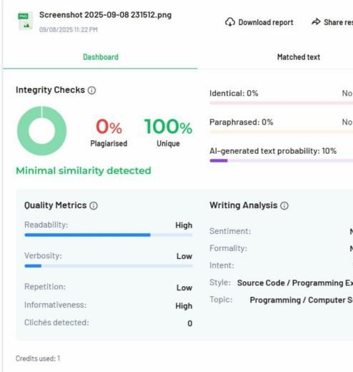
Date | 7-03-2026

